APPENDIX 3

PH GUIDANCE:
How to take the required respiratory swab/swabs.

Included is one swab per patient. This test will be used for testing for COVID testing initially. If this test is negative and further testing is recommended e.g. by the HPT for testing for flu, this will be facilitated using the same sample which will be tested again via arrangements within the lab.
Unlike with previous outbreaks where separate throat and nose swabs are required for each test, one swab should be used to take the sample from both body sites (serial swabbing).

Follow the instructions below for swabbing the throat and then use the same swab for swabbing the nose as per the nose swab instructions.

When a non-healthcare worker is taking the sample or when unable to obtain a throat swab from a patient, please just take a nose swab as instructed below.
Please ensure the sample containers, red topped Copan tubes, are labelled with the three patient identifying details (PIDs) of forename, surname and date of birth and the date the sample is being taken.

Throat swabs

- Wash your hands with soap and water and follow included guidance for donning appropriate Personal Protective Equipment (PPE).
- Place the patient in a position with a good light source. This will ensure maximum visibility of the tonsillar bed.
- Either depress the tongue with a spatula or ask the patient to say “aahh”. The procedure is likely to cause gagging and the tongue will move to the roof of the mouth. This can prevent accurate sampling, it is therefore important to quickly but gently rub the swab over the back of the throat as shown in the picture and if possible the tonsillar bed too. Care should be taken not to contaminate the swab by contact with the tongue or the oral mucosa on removal.
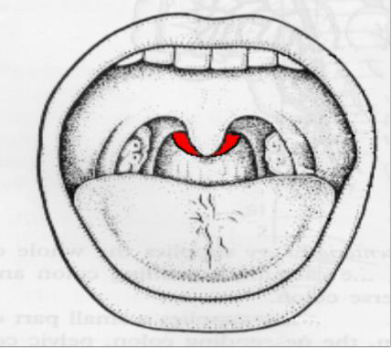
- Then as you will be serial swabbing, use the same swab to take the nose swab.

Nose/nasal swabs

- Insert the swab into the nose very gently along the floor of the nose (not upwards) JUST about one inch (2cms) inside one of the nostrils and twist gently around the inside the nose. Please repeat this for the other nostril, with the same swab, to obtain adequate material. Please do this gently – no force is needed, and you do not have to push far into the nostril.
- Place into the red topped Copan tube and break off the shaft of the swab at the red line.
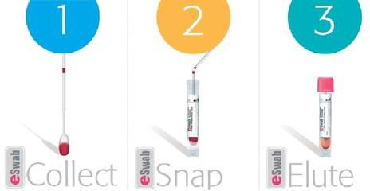

- Replace the lid of the Copan tube securely and decontaminate the outside of the container.
- Place labelled Copan tube inside the rigid, white transport container
- Ensure that all highlighted sections are completed on the E28 request form

DO ONE SWAB IN THIS WAY FOR EACH PERSON BEING TESTED.

- Follow included guidance for removal of PPE.
- Wash your hands with soap and water.

Please ensure the following has been completed for each patient:

- Hand hygiene performed before and after wearing PPE
- That one swab is used for sampling both the nose and throat (or just nose if indicated).
- Correct PPE is worn and removed as per guidance.
- The Copan tubes are labelled with a minimum of three PIDs and the sample date.
- All containers are securely closed.
- Provide the courier with all swabs and completed paperwork to forward onto the laboratory for testing.

