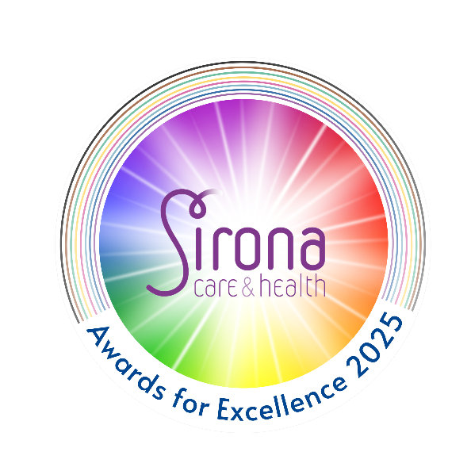
Awards for Excellence 2025 Nomination Form
I Think They Deserve It Award
Nominations open until 1 August
Please complete this form if you are a member of the public and would like to nominate a Sirona staff member for the outstanding level of care they have provided to you, or someone you know.
The information included on this form will be used only for the nomination process and the Awards for Excellence. If you have any queries please email sirona.communications@nhs.net
Email address for this individual/team
Your name
Your email address Contact number

Full name of the individual/team that you are nominating
Location/address of individual/team that you are nominating
Which team/service do they work for?
If you know their job title please state this below

Please return this form to:
Sirona.communications@nhs.net

Hand it to a Sirona member of staff in a sealed envelope with ‘Sirona Awards’ written on it

Or by post to:
F.A.O Awards team,
Sirona care & health
Badminton Road Office, Badminton Road, Yate
BS37 5AF

Why do you think this individual/team deserves to win this award? (give as much information as possible to support your nomination and make it stand out, please feel free to continue on additional pages if you need to) *
If the person you nominate is a winner of this category, we may contact you to see if you would be happy to take part in a short 'winners video' we may produce.
I am happy to be contacted / I do not wish to be contacted
(please delete as appropriate)

